## Top 5 Classification Algorithms in Machine Learning

### Popular Classification Algorithms:

* [**Logistic Regression**](https://monkeylearn.com/blog/classification-algorithms/#logistic-regression)
* [**Naive Bayes**](https://monkeylearn.com/blog/classification-algorithms/#naive-bayes)
* [**K-Nearest Neighbours**](https://monkeylearn.com/blog/classification-algorithms/#knn)
* [**Decision Tree**](https://monkeylearn.com/blog/classification-algorithms/#decision-tree)
* [**Support Vector Machines**](https://monkeylearn.com/blog/classification-algorithms/#svm)

### 1 - **Logistic Regression**

Logistic regression is a calculation used to predict a binary outcome: either something happens, or does not. This can be exhibited as Yes/No, Pass/Fail, Alive/Dead, etc

***P(Y=1|X) or P(Y=0|X***

It calculates the probability of dependent variable *Y*, given independent variable *X*.

2- [**Naive Bayes**](https://monkeylearn.com/blog/practical-explanation-naive-bayes-classifier/)calculates the possibility of whether a data point belongs within a certain category or does not.

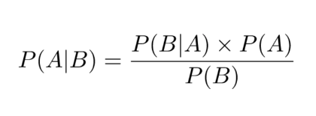

3- **K-nearest Neighbours**

K-nearest neighbours (k-NN) is a pattern recognition algorithm that uses training datasets to find the *k* closest relatives in future examples.

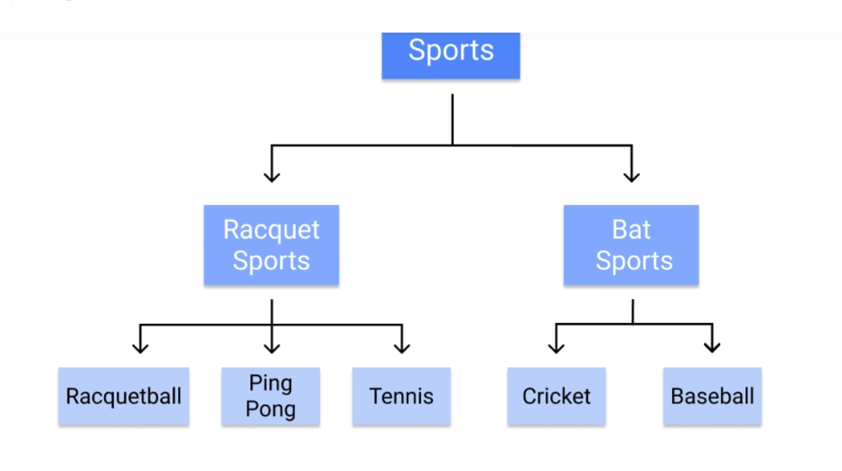

5**- Support Vector Machines :**

A [support vector machine (SVM)](https://monkeylearn.com/blog/introduction-to-support-vector-machines-svm/) uses algorithms to train and classify data within degrees of polarity, taking it to a degree beyond *X/Y* prediction.